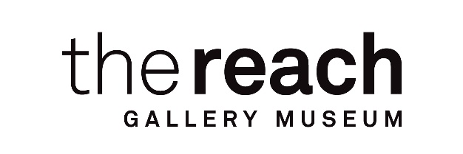
2026 YCW-HO Employment Opportunity
Title: Curatorial Programs Assistant
Duration: 13 weeks
Start & End Dates: June 1, 2026–August 28, 2027

Rate of Pay: $22.50/hr
Hours: 40 hrs / week
Work Days: Monday-Friday, with occasional weekends for events

The Reach is seeking motivated and mature candidates who love working with children and are passionate about arts education, particularly in informal learning environments like art galleries and museums, for two Cultural Programs Assistant positions. During the 13-week work term, the Cultural Programs Assistants will gain practical, hands-on experience teaching art to children and youth during our full-day, week-long summer camps. The hourly rate for this position is $22.50 plus 4% vacation pay.

Responsibilities:

Under the supervision of the Curator of Learning & Community Engagement, the Cultural Programs Assistants will:
• Develop summer camp programming through the creation of educational art lessons and activities.
• Deliver 6 weeks of full day summer art camps to groups of children (ages 6-10) and youth (ages 11-13).
• Facilitate hands-on activities at select community outreach activities at local festivals and public workshops
• Maintain attendance records, evaluate programming and assist in gathering participant survey feedback.

Skills and Experience:

The Cultural Programs Assistants will gain practical skills, knowledge, and hands-on experience in:
• Educational program development and classroom management.
• Project management, evaluation, and public engagement.
• Art gallery and museum principles and practices.

Qualifications:

If you are a returning post-secondary student studying early-childhood education, art education, or visual art and love working with children, then this opportunity is for you! We are seeking candidates with the following:
•• Interest in early-childhood education and/or arts education.
• Experience teaching children in informal learning environments.
• Knowledge of program development and coordination OR equivalent experience in community leadership, cultural knowledge sharing, or related activities.
• Strong administrative, organizational, and time management skills.
• Excellent communication and interpersonal skills, with an ability to engage diverse audiences effectively.
• Familiarity with digital tools such as Microsoft Office, Canva, Constant Contact, and social media platforms.
• Ability to work independently and collaboratively in a fast-paced environment.

Assets:

• Training or experience in early-childhood education.
• Experience teaching children from diverse cultural backgrounds.
• Familiarity with a variety of visual art processes and techniques.
• First Aid Certification.
• A valid driver’s license is preferred but not mandatory. Candidates must be able to arrange reliable transportation toThe Reach.

Working Conditions:

• Combination of on-site work at The Reach and off-site partner locations
• Occasional weekend work is required
• Physically active role involving standing for extended periods, lifting up to 50 lbs. and classroom setup.
• Ongoing public interaction with participants, and partners

Equity and Inclusion:

The Reach is an equal opportunity employer and encourages applications from candidates who are Indigenous, visible minorities, persons with disabilities, LGBTQ2+, or newcomers to Canada. We value lived experiences and Indigenous ways of knowing as essential contributions to this role. Candidates who bring cultural knowledge or community experience are encouraged to apply, even if they do not meet all formal requirements.

Eligibility:

Applicants wishing to be considered for this job must be registered for the YCW online candidate inventory. The Reach will only interview candidates who meet the eligibility criteria for participation in Young Canada Works in Heritage Organizations, as outlined: https://www.canada.ca/en/canadian-heritage/services/funding/young-canada-works/students-graduates/heritage-organizations-students.html

Successful applicants will be required to have a valid criminal record check on file.

How to Apply:

Cover letters and resumes will be accepted electronically and must be emailed as a single PDF to the Curator of Learning & Community Engagement, Andrea Orlosky, at aorlosky@thereach.ca. In your cover letter, please describe a time when you had to teach someone something. Please include your name and "Cultural Programs Assistant Application" in the subject line. Applications must be received by 11:59 PM on Sunday, May 10, 2026.

